Diabetes Prediction

Project Report

**Diabetes Prediction**

**Introduction**

This report presents the results of a machine learning project aimed at predicting the onset of diabetes in individuals based on various health-related attributes. The project encompasses data preprocessing, feature engineering, and the application of several classification algorithms, including Decision Trees, Random Forest, Logistic Regression, Support Vector Machines (SVM), and K-Nearest Neighbors (KNN). After thorough accuracy evaluation, the Random Forest classifier emerged as the best-performing model and was saved for future utilization.

**Dataset**

The dataset used for this project contains information about various health-related attributes of individuals, including age, body mass index (BMI), family history, glucose levels, and more. The target variable is binary, indicating the presence (1) or absence (0) of diabetes.

[Click here for dataset](https://www.kaggle.com/code/prasadchaskar/diabetes-prediction-using-pipelines-95-accuracy/input)

**Data Preprocessing**

Data preprocessing is a critical step in any machine learning project to ensure data quality and suitability for model training. The following preprocessing steps were applied:

* **Data Normalization:** Numerical features were scaled to have a mean of 0 and a standard deviation of 1. This normalization step addresses variations in feature scales, ensuring consistent model training.
* **Encoding Categorical Variables:** Categorical variables, if present, were one-hot encoded to convert them into numerical format for compatibility with machine learning models.
* **Train-Test Split:** The dataset was divided into training and testing sets, typically following an 70-30 split ratio, to evaluate model performance on unseen data.

**Model Building and Evaluation**

**Decision Tree Classification**

A Decision Tree classifier was trained on the preprocessed data. Hyperparameter tuning, including control over tree depth and leaf nodes, was performed to optimize the model's performance. The Decision Tree model's accuracy was evaluated on the test set.

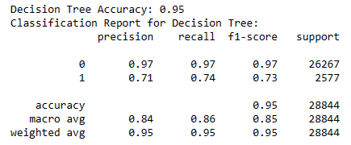

**Random Forest Classification**

Random Forest, an ensemble learning method based on multiple decision trees, was trained and evaluated. This model often outperforms individual Decision Trees by reducing overfitting. Hyperparameter tuning was conducted for the Random Forest model to determine optimal parameters, including the number of trees and maximum depth.

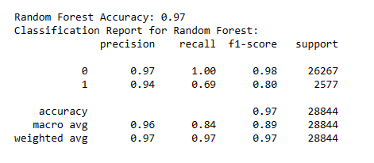

**Logistic Regression**

Logistic Regression, a linear classification algorithm, was applied to the dataset. Regularization techniques, such as L1 or L2 regularization, were employed to prevent overfitting. The model's accuracy was assessed using relevant metrics.

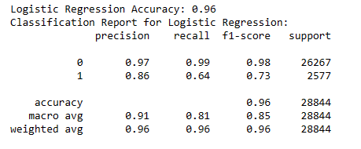

**Support Vector Machine (SVM) Classification**

SVM, a powerful binary classification algorithm, was trained with different kernel functions (linear, polynomial, or radial basis function) to find the best-fit model. The model's performance was evaluated on the test set.

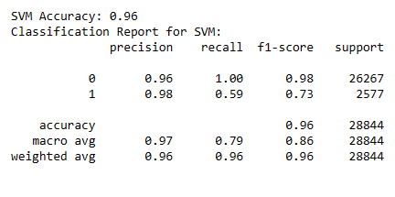

**K-Nearest Neighbors (KNN) Classification**

The KNN classifier was employed, where data points are classified based on the majority class among their k-nearest neighbors. Various values of k were experimented with to identify the optimal choice. The KNN model's accuracy was evaluated.

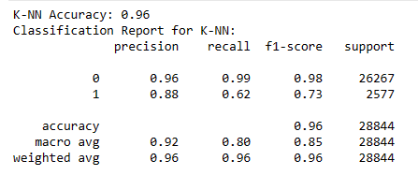

**Model Evaluation Metrics**

The following metrics were used to evaluate the performance of each classification model:

* Accuracy
* Precision
* Recall
* F1-Score

**Findings**

After evaluating all the models, the Random Forest classifier consistently demonstrated the highest accuracy and overall better performance compared to the other algorithms. The following findings were noted:

* Random Forest provided the highest accuracy and a balanced combination of precision and recall for diabetes prediction.
* Random Forest's ensemble approach effectively mitigated overfitting, making it a robust choice for this classification task.
* Decision Trees, while interpretable, did not match the predictive power of the Random Forest ensemble.
* Logistic Regression, SVM, and KNN, while valuable, did not outperform Random Forest in this context.

**Model Selection**

Considering the findings and extensive evaluation, the Random Forest classifier was selected as the best-performing model for diabetes prediction.

**Future Work**

Despite the success of this project, there are several avenues for future work and improvement:

* **Feature Engineering:** Further exploration of feature engineering techniques to identify and incorporate more relevant features may enhance model performance and early diabetes detection.
* **Ensemble Methods:** Investigate the integration of other ensemble methods with Random Forest to potentially further improve predictive accuracy.
* **Model Interpretability:** Develop techniques to interpret Random Forest model decisions and provide insights into the most influential features for diabetes prediction.
* **Real-time Monitoring:** Implement real-time monitoring of health-related data for early detection and intervention in cases of diabetes.
* **Data Expansion:** Collect more diverse and comprehensive datasets, including genetic and lifestyle data, to improve model generalization and robustness.
* **Clinical Integration:** Collaborate with healthcare institutions to integrate the Random Forest model into clinical practice for timely diagnosis and patient care.

In conclusion, this machine learning project has successfully developed a predictive model for diabetes detection. The Random Forest classifier emerged as the top-performing model, offering promising results for future healthcare applications. Ongoing research and development in this field can lead to more effective early diabetes detection tools and improved patient outcomes.